Activity Guide - Personal Favicon Project

Objectives
- Encode a 16 x 16 pixel image with at least 12 bits per pixel.
- Create and encode a color image of your own design.
- Explain the benefits of using hexadecimal numbers for representing long streams of bits.
Overview
A favicon is a small image, usually 16x16 pixels, that is typically shown in a web browser’s address bar next to the title of the page or web address for a particular site. It is typically a small version of a company logo or some other symbol for the site. A favicon for Code.org is shown to the right.

Favicons are designed by artists and programmed into web pages by web designers. Below are some examples of favicons—you might recognize some!
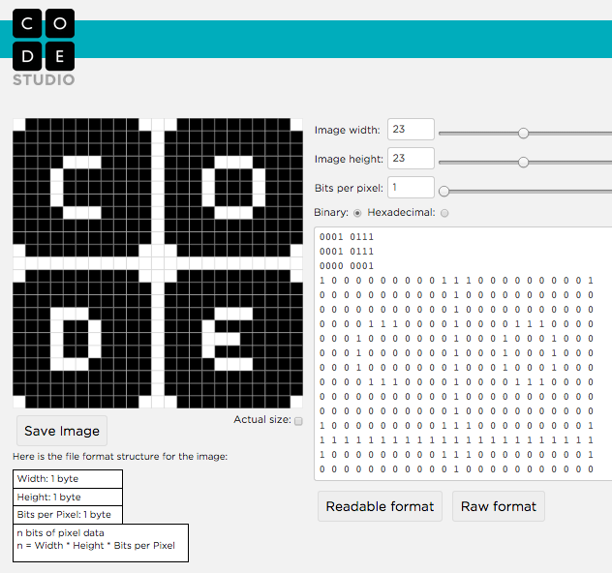

Do a google search for Favicon and see what comes up.

Directions

- Create a personal 16x16 favicon and encode it using the Pixelation Widget on the final level of this lesson in Code Studio.
- The image you make should represent your personality in some distinctive way.
- Optional: After you have finished your favicon, share it with others in the class by sending them the bits with the Internet Simulator Widget!

Requirements

- The icon must be 16x16 pixels.
- You must use the Pixelation Widget to encode the bits of color information.
- The image must be encoded with at least 12 bits per pixel.

Things to think about

- A simple design with a few basic colors is probably the best solution. How could you use more colors?
- Plan ahead: Sketch your design before starting to encode the bits. You might want to use a tool to help you draw small images. Suggestions:
  - Favicon & App Icon Generator: http://favicon-generator.org/editor/
  - Make Pixel Art: http://makepixelart.com/free/

Tip
Consider switching the Pixelation tool into HEX mode (base-16) instead of binary. This will enable you to more easily use a greater number of bits. If you use hex, you should consider using 12-bits-per-pixel (4096 colors!) because that maps to exactly 3 hex digits, which also maps easily to RGB—1 hex digit for each. For example, to make a teal color (shown right) whose 12-bit binary value is: 001110101011, we can represent it in hex much more easily as 3AB. Here is the breakdown:

 | R | G | B
binary | 0011 | 1010 | 1011
hex | 3 | A | B

To make a darker shade, just choose a smaller hex digit for the channel of color you want to affect, such as 3A5 (which turns down the amount of blue light).

