Name(s)_________________________________________ Period ______ Date ________________ Unit 2 Lesson 6
 | Rapid Research - Format Showdown | 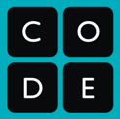

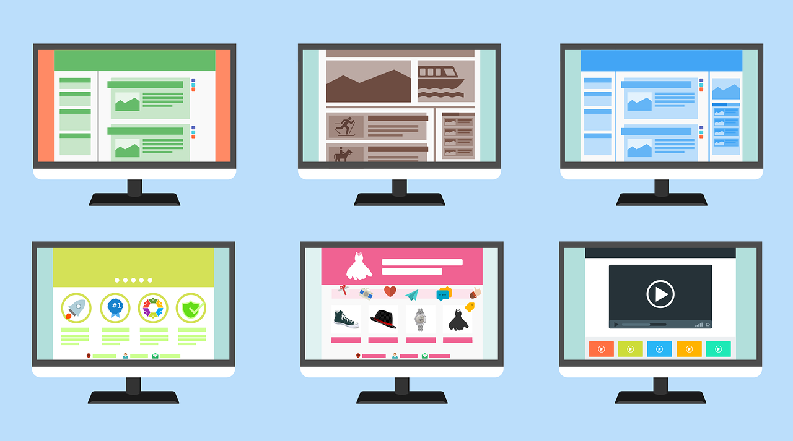
Project Overview: Format Showdown
Sharing text, images, video, and audio is increasingly how people communicate. For any of this to work we need shared file formats. Over the last few decades there have been many formats for each kind of file, and at any point in time there’s usually many formats to choose from. Why so many choices, and which one is best?

For this project you will be researching a popular file format to understand what it does, how it works, and what makes it important. Then you will create a computational artifact sharing the results of your research and arguing why your format is the best!

Computational Artifact
You will choose a file format that you wish to research. Based on your research you will create both a computational artifact. Important questions will include:
- The history of the format
Note: This assignment has been revised from its original version on code.org (in that we will not be completing the One Page Paper)
- Key information about how it works
- Advantages and disadvantages of this format
- How it compares to other similar formats

General Process & Requirements
- Choose a format using the guide below
- Conduct your research by following the research guide (below)
- Design a computational artifact (instructions on one-page template)

Choose Your Format
Some Suggestions: Use the list below to help you begin your research. Just because you haven’t heard of a format before doesn’t mean that it isn’t interesting or important!

Image Formats | Audio Formats | Video Formats | Other Formats
BMP  JPEG 2000  GIF  TIFF  PDF  RAW  WebP  HEIF | WAV  AAC  OGG  FLAC  ALAC  WMA  AIFF | MP4  OGG  Quicktime  AVI  FLV | DOCX  ODT

Want to find more?: This is just a short list of formats to get your research started. If you like you can skim this list of formats from Wikipedia to find more to check out. https://en.wikipedia.org/wiki/List_of_file_formats

Just pick one!: Don’t spend more than 5-10 minutes deciding on a format. Pick one and then move on to the research guide below.

Research Guide - Format Showdown

Conduct Your Research
You’ll want to find recently published articles from authoritative sources. As you’ve already seen in the world of CS research may mean using sources like “Wikipedia” or even online forums to begin your search. From there, however, try to find your way to the organizations who actually created the various formats. They’ll usually be the best source of information. You may encounter some technical language, but keep an eye out for familiar terminology and topics covered in this unit to be your guide.

Key Information to Find
- Format Basics: What type of file is it (audio / video / document / image etc.)? Where is (or was) this format normally used?
- Format History: Who created it? When? What else was around at the time? Is it still in use? Is it open source or do you need to pay for a license?
- Compression: Does it use compression? Lossy or lossless? What’s the average file size? On average how much (as a percent) does it compress a file?
- Advantages: What situations is your format good at? What advantages does it present over similar formats?
- Disadvantages: What situations is your format bad at? Are there other formats that perform better?

Use the tables below to keep track of your information; you can also add more if you like. You’ll need to include at least 3 sources of information but you can use more.

My Format: _________________________________________________________________

Reference Name:  Year Published: | URL:
Key Information

Reference Name:  Year Published: | URL:
Key Information

Reference Name:  Year Published: | URL:
Key Information

