Activity Guide: Rapid Research - Data Innovations

Project Overview: Data Innovations
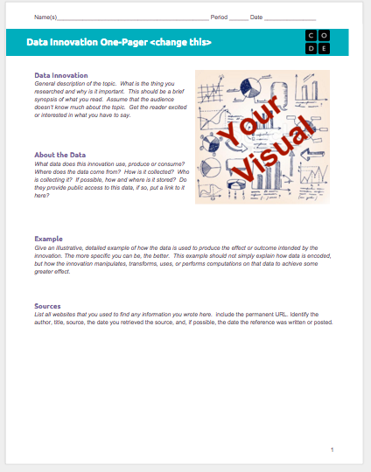
In this small project, you will quickly research a computing innovation of your choice and present a “one-pager” about it. The computing innovation should be one that produces, uses, consumes or is “driven” by data in some way.

The One-Pager
In the professional world it is common to ask someone to do a bit of online research and then prepare a one-page summary or “one-pager” to show the rest of the team or colleagues about the highlights of what you found. For this project you will prepare a one-pager that explains how some technological innovation uses data.

General Process & Requirements
- Review the One-Pager Template and the Rubric below.
- Choose your innovation using the guide below to help.
- Conduct your research by following the Research Guide below.
- Complete the one-pager.

Choosing Your Innovation
You should choose an innovation related to big data that you find personally relevant or interesting. For the purposes of this project, you may need to use a broad definition of an “innovation,” and it doesn’t necessarily mean that it has to be a new invention. In particular, we’re looking for an innovation that uses data.

Brainstorming:
Start by simply going to your favorite search engine and entering the name of a thing you are interested in, followed by the word “data” or “big data.” For example: “soccer big data,” “shopping big data,” “music big data.” It might take some poking around, but you will find a few interesting things.

Make sure you can easily find at least one or two reputable sources for your innovation and how it uses data.

Other Ideas:
- Smart grids, smart buildings, smart homes
- The data behind your favorite app
- Online shopping trends/recommendations
- Crowdsourcing
  - Crowd source inventions and funding (Kickstarter, Quirky, GoFundMe)
  - reCAPTCHA
  - GWAPs - Games With A Purpose
- Assistive technologies - aiding human vision, hearing, movement, etc.
- Machine learning
- Sports analytics
- Any kind of science: physics, biology, chemistry, astronomy, etc.

Research Guide - Data Innovation

Conducting Your Research
You already have some practice finding good resources online. You’ll want to find recently published documents from authoritative sources. There is no need to use overly technical documents, but keep an eye out for familiar terminology and topics.

Key Information to Find
- Purpose: the need, goal, or problem that led to the creation of the innovation. This is “what” the innovation was designed to do.
- Function: how the innovation actually accomplishes its purpose. This typically means describing the way it consumes, produces, or transforms data. This is “how” the innovation actually works.
- Beneficial Effect: try to find a group that has benefitted from the innovation. Describe the specific impact of the innovation on them in terms of society, economy, or culture.

Use the tables below to keep track of your information; you can also add more if you like. You’ll need to include at least 3 sources of information but you can use more.

My Innovation: _________________________________________________________________

Reference Name:  Year Published: | URL:
Key Information

Reference Name:  Year Published: | URL:
Key Information

Reference Name:  Year Published: | URL:
Key Information

Rubric - Data Innovation One-Pager

One-Pager Rubric

Component | 1 | 2 | 3 | Score
Sources & Visual
Sources | Research Guide includes references to fewer than three sources and the sources listed are not recent and authoritative. Most In-Text Citations are missing. Source information is not included. | Research Guide includes references to fewer than three sources or the sources are not recent and authoritative. Some In-Text Citations were used. Source information may not have been included. | Research Guide includes references to at least three recent, authoritative sources. All In-Text Citations tie into the sources that were used. Source information included for all sources used.
Visual | Visual does not substantially contribute to expanding the understanding of the innovation provided in the written responses. | Visual may be appropriate but largely repeats information in the written responses, or is only loosely related to the innovation. | Visual is well chosen and enhances or augments the information in the written responses.
Written Responses
Purpose | The description does not provide a clear explanation of the purpose. It’s possible that this response clearly explains the “function” of the innovation but not the goal or objective that led to its creation. | The description explains what the innovation does, but not the purpose - it’s missing the “why”, or doesn’t directly state why the innovation was created. | The purpose description includes rich details. The specific need or goal that led to the creation of the innovation is noted.
Function | A brief description of the data used by this innovation is given but only includes superficial detail or generic descriptions. | A description of the data used by this innovation is given but lacks sufficient detail to give a clear picture of exactly how the innovation uses data or what is innovative about it. | A clear description is given of what kind of data the innovation uses, how it’s collected, and by whom. It also explains how the innovation uses, produces, or consumes this data.
Beneficial Effect | Response does not identify a group affected nor an economic or cultural impact. Or the response is overly vague like “it affects society because…” | Describes the group affected OR the economic or cultural impact but not both. Or the response is vague about the group, or impact. | Response clearly identifies BOTH a group affected by the innovation AND an economic or cultural impact.

